**Coding Challenges - PetPals, The Pet Adoption Platform**  
  
1. Provide a SQL script that initializes the database for the Pet Adoption Platform ”PetPals”.

--create database

**create database PetPals**

use PetPals

2. Create tables for pets, shelters, donations, adoption events, and participants.

3. Define appropriate primary keys, foreign keys, and constraints.

4. Ensure the script handles potential errors, such as if the database or tables already exist.

create table tbl_pets (

petid int primary key identity(1,1),

name varchar(200) not null,

age int not null check (age >= 0),

breed varchar(200) not null,

type varchar(100) not null,

availableforadoption int not null

);

create table tbl_shelters (

shelterid int primary key identity(1,1),

name varchar(200) not null unique,

location varchar(500) not null

);

create table tbl_donations (

donationid int primary key identity(1,1),

donorname varchar(200) not null,

donationtype varchar(100) not null check (donationtype in ('Cash', 'Item')),

donationamount decimal(10,2) check (donationamount >= 0),

donationitem varchar(200),

donationdate datetime not null

);

create table tbl_adoptionevents (

eventid int primary key identity(1,1),

eventname varchar(200) not null unique,

eventdate datetime not null,

location varchar(500) not null

);

create table tbl_participants (

participantid int primary key identity(1,1),

participantname varchar(200) not null,

participanttype varchar(100) not null check (participanttype in ('Shelter', 'Adopter')),

eventid int,

constraint fk_participant_event foreign key (eventid) references tbl_adoptionevents(eventid)

);

5. Write an SQL query that retrieves a list of available pets (those marked as available for adoption) from the "Pets" table. Include the pet's name, age, breed, and type in the result set. Ensure that the query filters out pets that are not available for adoption.

**select name, age, breed, type from tbl_pets where availableforadoption = 1;**

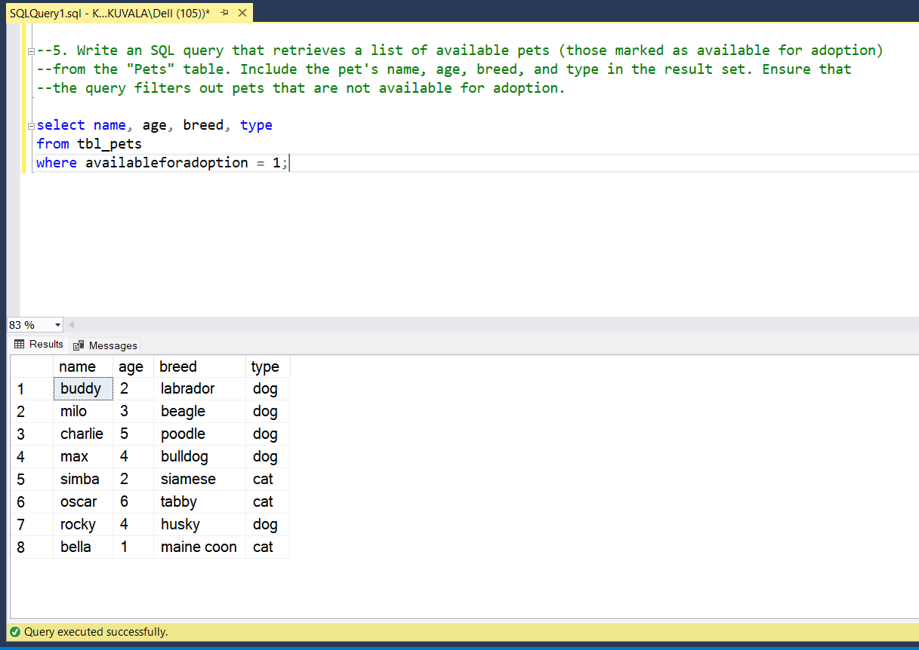

6. Write an SQL query that retrieves the names of participants (shelters and adopters) registered for a specific adoption event. Use a parameter to specify the event ID. Ensure that the query joins the necessary tables to retrieve the participant names and types.

**select p.participantname, p.participanttype from tbl_participants p**

**join tbl_adoptionevents a on p.eventid = a.eventid where a.eventid = 2;**

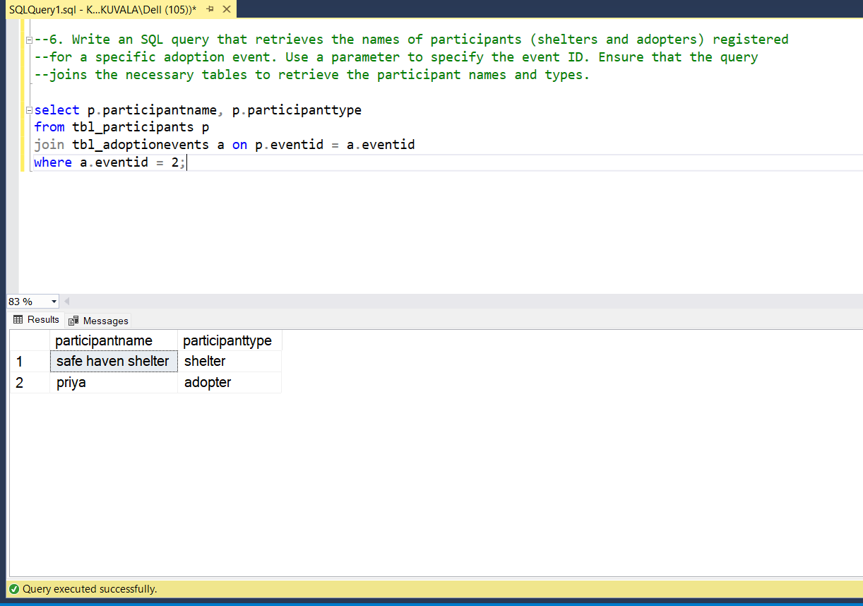

8. Write an SQL query that calculates and retrieves the total donation amount for each shelter (by shelter name) from the "Donations" table. The result should include the shelter name and thetotal donation amount. Ensure that the query handles cases where a shelter has received no donations.

**select s.name as shelter_name, coalesce(sum(d.donationamount), 0) as total_donation_amount**

**from tbl_shelters s left join tbl_donations d on s.name = d.donorname**

**group by s.name order by total_donation_amount desc;**

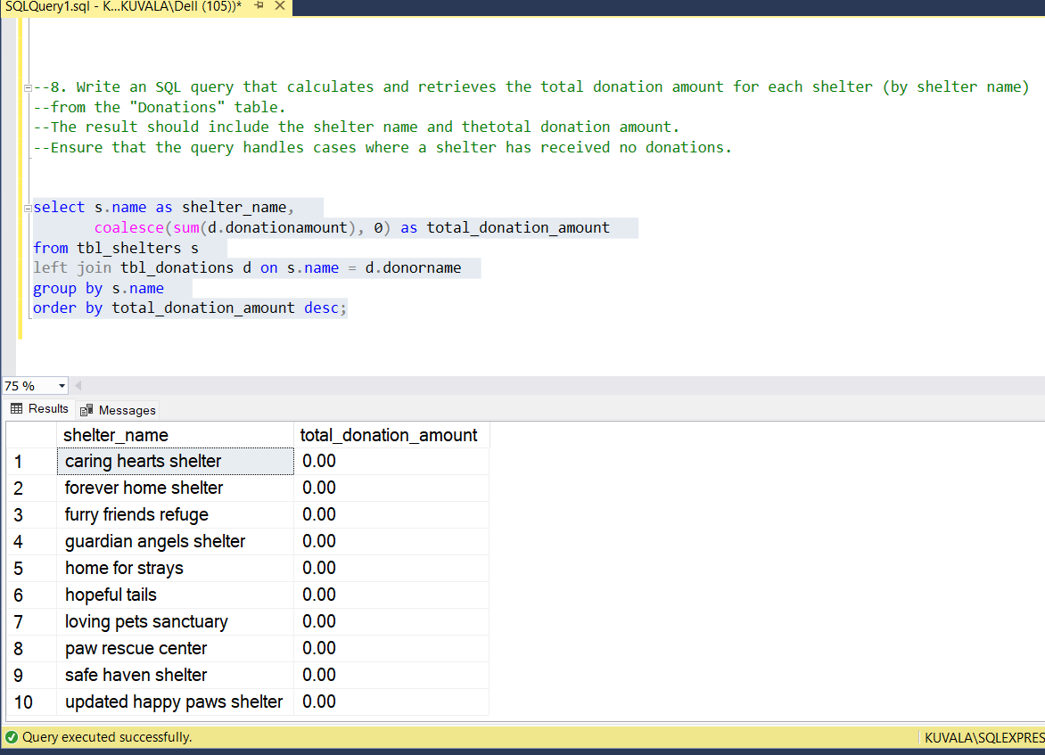

9. Write an SQL query that retrieves the names of pets from the "Pets" table that do not have an owner (i.e., where "OwnerID" is null). Include the pet's name, age, breed, and type in the resultuse above same table.

[As there no separate adoption table with owner_Id ,I assume that when availableforadoption = 1 which don’t have an owner and query goes like this below]

**select name, age, breed, type from tbl_pets where availableforadoption = 1;**

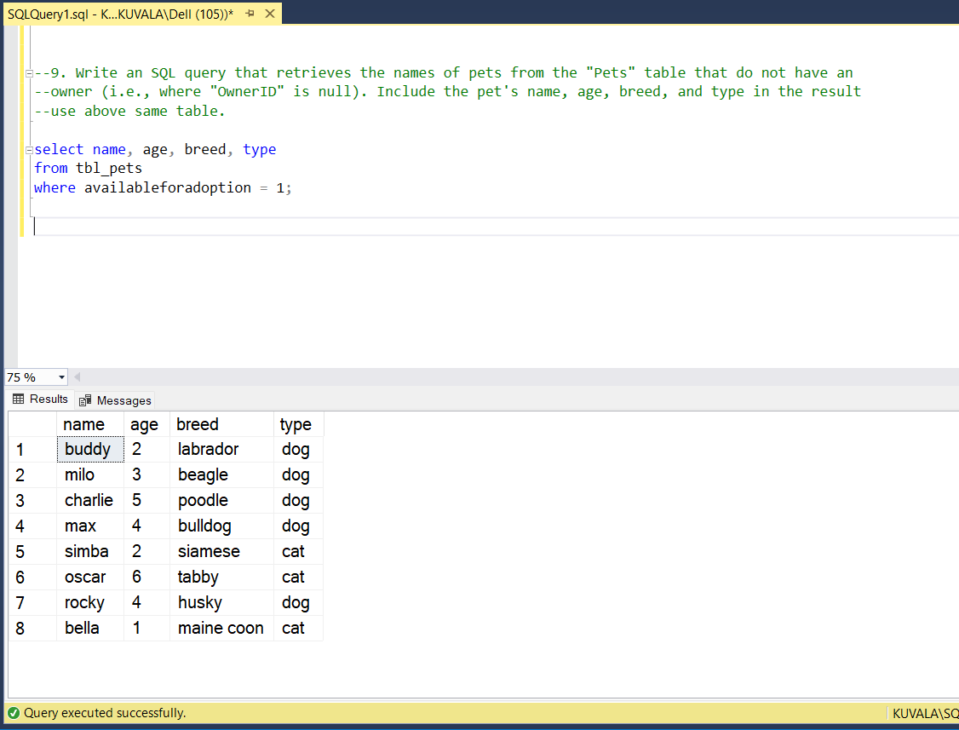

10. Write an SQL query that retrieves the total donation amount for each month and year (e.g.,January 2023) from the "Donations" table. The result should include the month-year and the corresponding total donation amount. Ensure that the query handles cases where no donations were made in a specific month-year.

**select format(donationdate, 'MMMM yyyy') as month_year, coalesce(sum(donationamount), 0) as**

**total_donation_amount from tbl_donations group by format(donationdate, 'MMMM yyyy')**

**order by min(donationdate);**

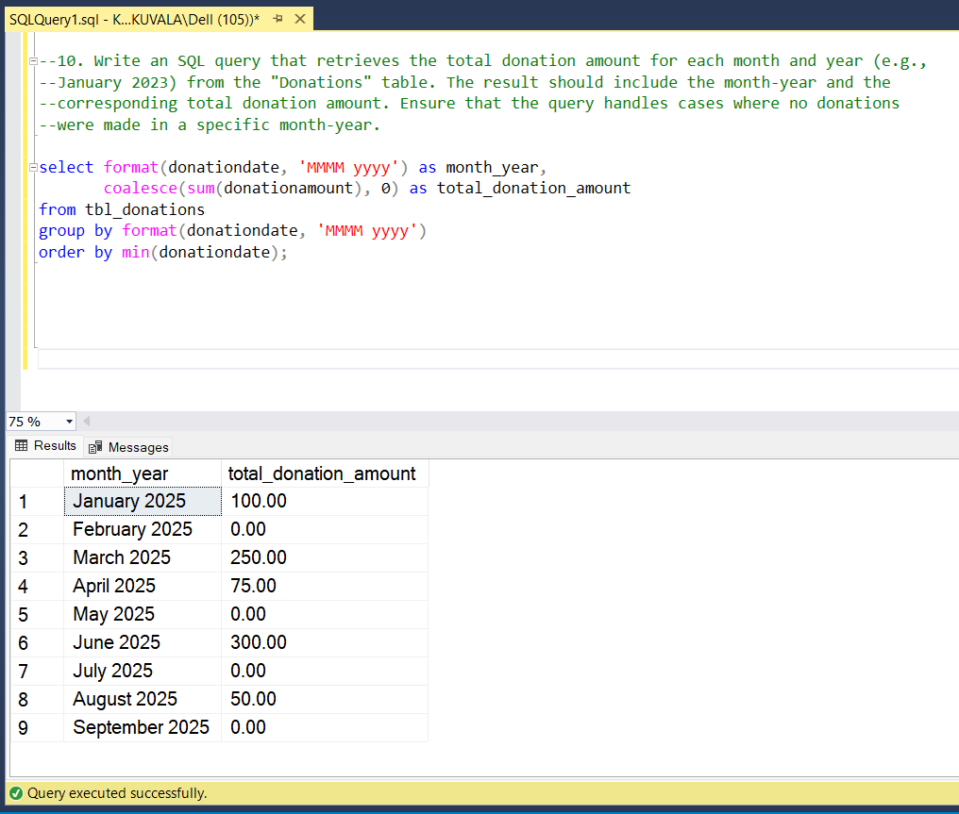

11. Retrieve a list of distinct breeds for all pets that are either aged between 1 and 3 years or older than 5 years.

**select distinct breed from tbl_pets where (age between 1 and 3) or (age > 5);**

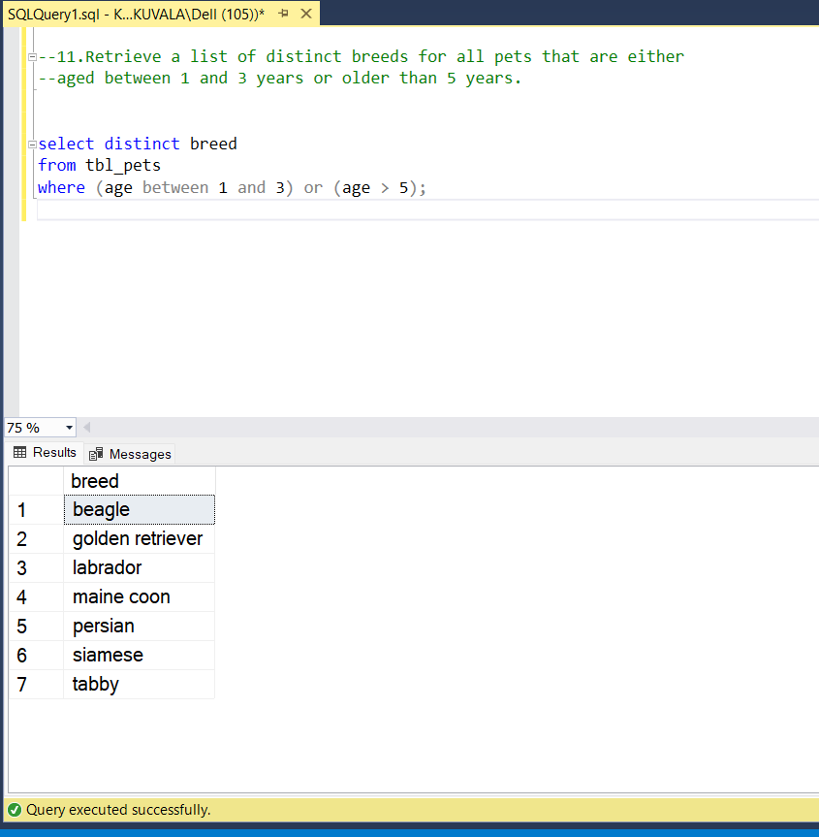

12. Retrieve a list of pets and their respective shelters where the pets are currently available for adoption.

[As currect schema doesn’t have **link** between tbl_pets and tbl_shelters,I modify the table then written the query]

**select p.name as pet_name, p.age, p.breed, p.type, s.name as shelter_name from tbl_pets p**

**join tbl_shelters s on p.shelterid = s.shelterid where p.availableforadoption = 1;**

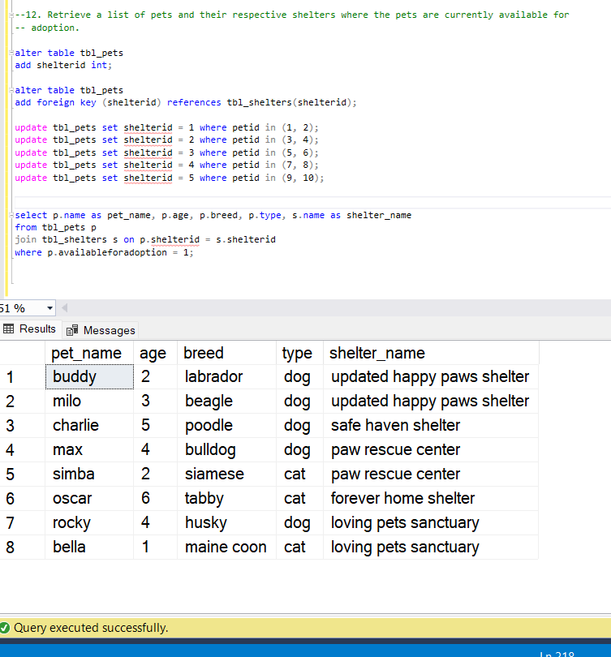

13. Find the total number of participants in events organized by shelters located in specific city.Example: City=Chennai.

**select count(distinct p.participantid) as total_participants**

**from tbl_participants p join tbl_adoptionevents e on p.eventid = e.eventid**

**join tbl_shelters s on e.location = s.location where s.location = 'chennai';**

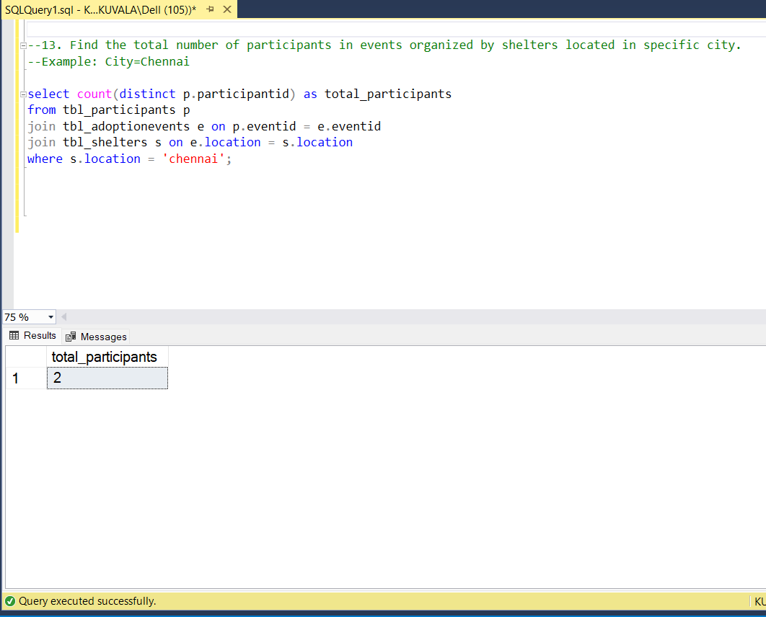

14. Retrieve a list of unique breeds for pets with ages between 1 and 5 years.

**select distinct breed from tbl_pets where age between 1 and 5;**

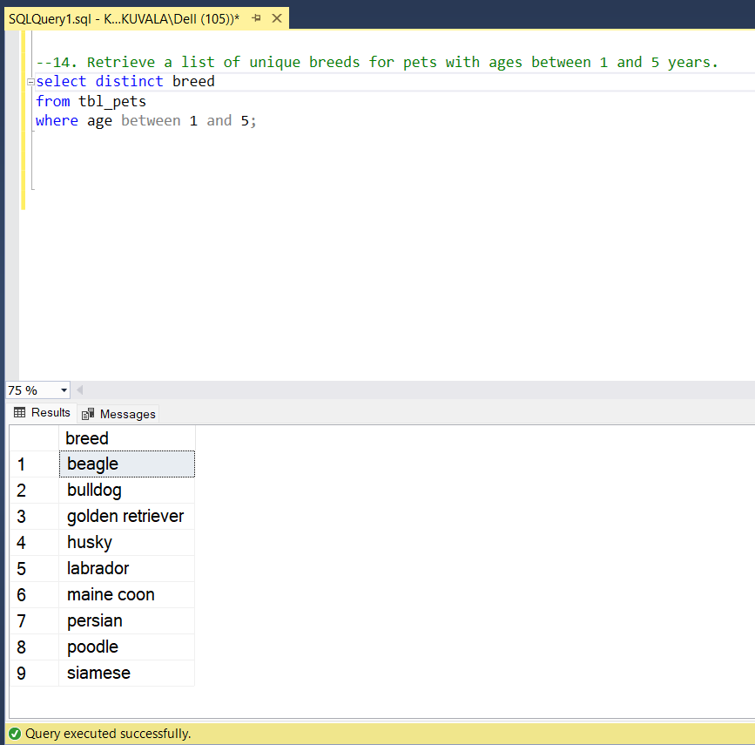

**15. Find the pets that have not been adopted by selecting their information from the 'Pet' table.**

select petid, name, age, breed, type from tbl_pets where availableforadoption = 1;  
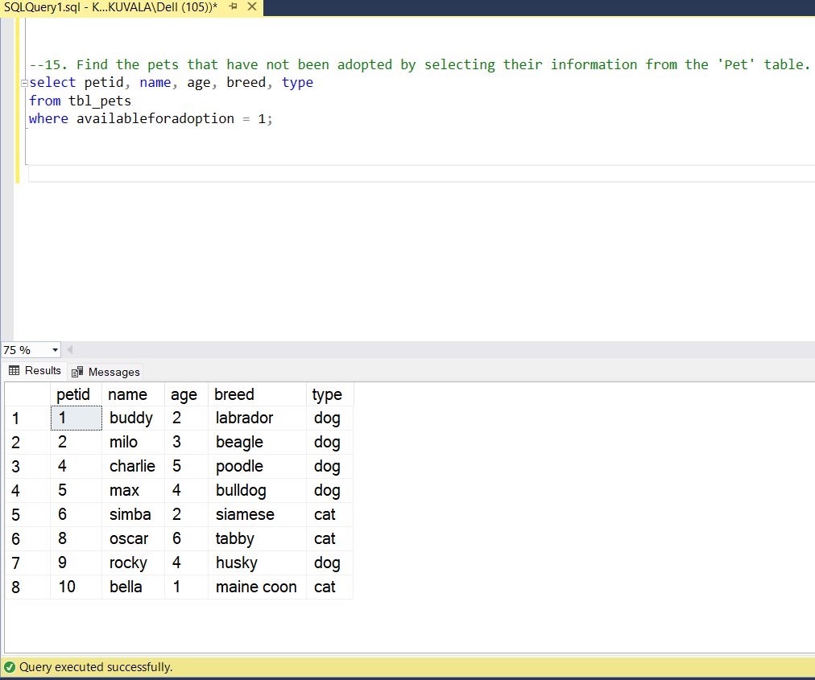

16. Retrieve the names of all adopted pets along with the adopter's name from the 'Adoption' and 'User' tables.

[Since schema doesn’t include **adoption records** or a **user table** in one table (which store adopter details) so to perform this query I have created an table linking both as tlb_adoption then query goes like this ..]

**select p.name as pet_name, a.adoptername from tbl_pets p join tbl_adoptions a on p.petid = a.petid;**

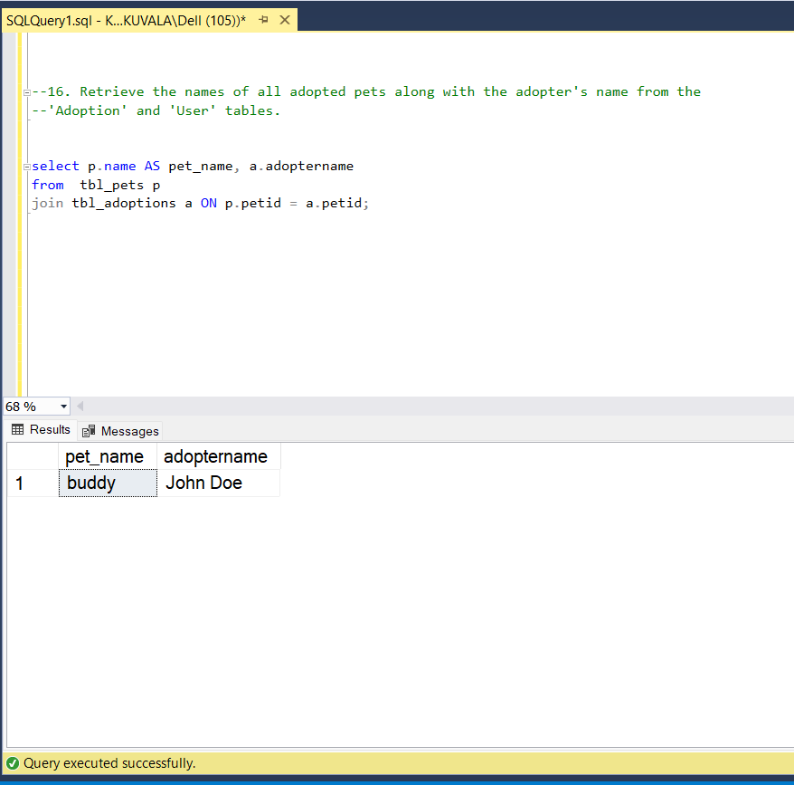

18. Find pairs of pets from the same shelter that have the same breed.

**select p1.name as pet1, p2.name as pet2, p1.breed, s.name as shelter_name**

**from tbl_pets p1 join tbl_pets p2 on p1.shelterid = p2.shelterid and p1.breed = p2.breed and p1.petid < p2.petid**

**join tbl_shelters s on p1.shelterid = s.shelterid order by s.name, p1.breed;**

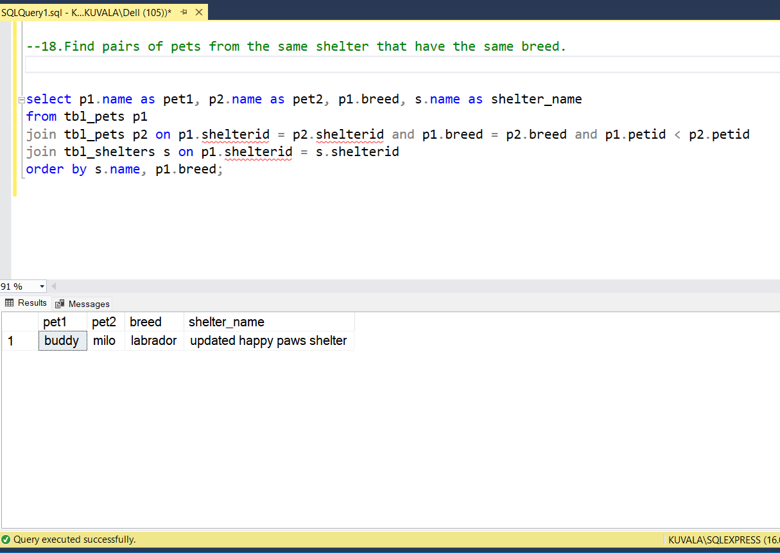

19. List all possible combinations of shelters and adoption events.

**select s.name AS shelter_name, e.eventname AS adoption_event**

**from tbl_shelters s cross join tbl_adoptionevents e order by s.name, e.eventname;**

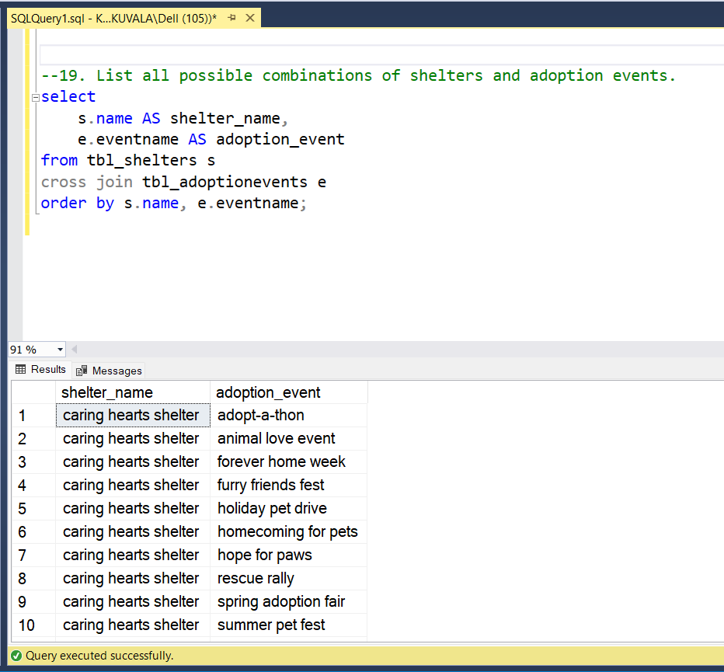

20. Determine the shelter that has the highest number of adopted pets.

**select top 1 s.name as shelter_name, count(p.petid) as adopted_pets_count from tbl_shelters s**

**join tbl_pets p on s.shelterid = p.shelterid where p.availableforadoption = 0**

**group by s.name order by adopted_pets_count desc;**

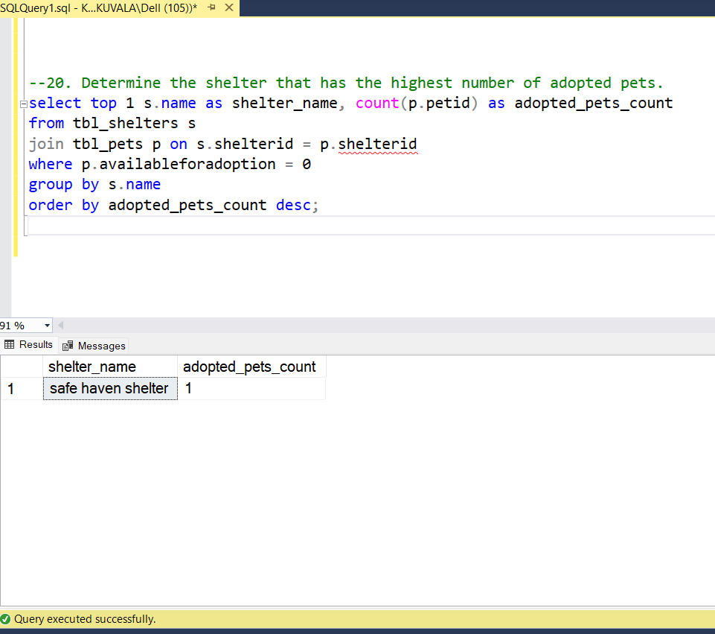

End.